//Chap 1

//Q1

alert("Good Morning User \nWelcome to My Site")

//Q2

alert("Error! Please enter a valid password.")

//Q3

alert("Welcome to JS Land... \nHappy Coding!")

//Q4

alert("Welcome to JS Land...")

//Q5

alert("Happy Coding!")

//Q7(a)

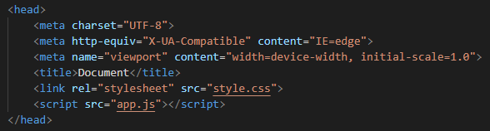

//Q7(b)

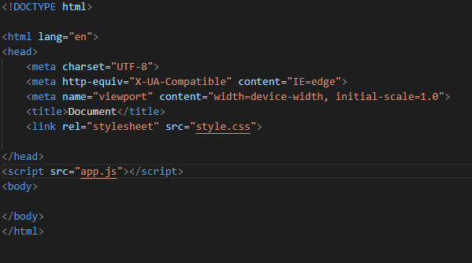

//Q7(c)

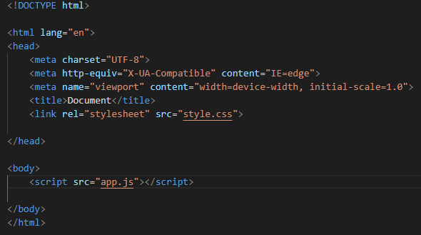

//Q7(d)

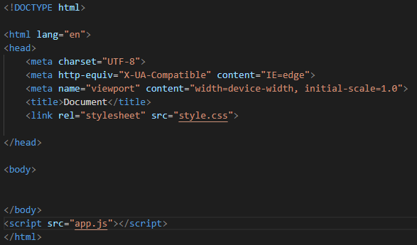

//Chap 2

//Q1

var username="";

//Q2

var MyName="Saraib Aqeel";

alert(MyName);

//Q3

var message="Hello World";

alert(message);

//Q4

var Name="Jhone Doe";

alert(Name);

var Age=15;

alert(Age + " Years Old");

var Certificate="Certified Mobile Apllication Development";

alert(Certificate);

//Q5

var Pizza="PIZZA \nPIZZ \nPIZ \nPI \nP  ";

console.log(Pizza);

//Q6

var email="Saraibaqeel4@gmail.com";

var myemail="My Email Address is ";

alert (myemail + " " + email);

//Q7

var book="A smarter way to learn Javascript";

var me="I am trying to learn from ";

alert (me + " " + book);

//Q8

document.write("Yah! I can write HTML contect through Javascript");

//Q9

var design="\n▬▬▬▬▬▬▬▬▬ஜ۩۞۩ஜ▬▬▬▬▬▬▬▬▬";

alert(design);

document.write(design);